Our Values: | Our Mission:  In collaboration with the IWS, MOE and whanau, to provide programmes for our students that will enable them to:  - Maximise their learning, strengths and potential and develop positive and pro-social behaviours.  - Enhance their cultural identity and self- efficacy.  - Successfully transition back to their  whanau, school and community.
Marutau -
Safety
Takohanga -
Respect
Manaakitanga -
Responsibility
CHARTER 2023
Our strategic priorities for the next year promote student learning, engagement, progress and achievement through…
1. Student Learning | 2. Effective Teaching | 3. Leading the School
What this will look like….  The school fosters | What this will look like…. | What this will look like….
student achievement by | Staff are recognised | Our service is cost
providing teaching and | as leaders in | effective, caters for the
learning programmes | providing for | needs of all students,
that incorporate the | children and | and represents best
National Curriculum and | adolescents with | practice. The school
are underpinned by the | complex intellectual | inclusive, culturally
key competencies. All | needs and/or | responsive and safe
learning is delivered in a | behavioural needs, | physically and
24/7 teaching and | to maximise student | emotionally. The school
learning environment | learning goals. | has strong relationships
where ‘living is learning’. |  | with whanau and
 |  | stakeholders.
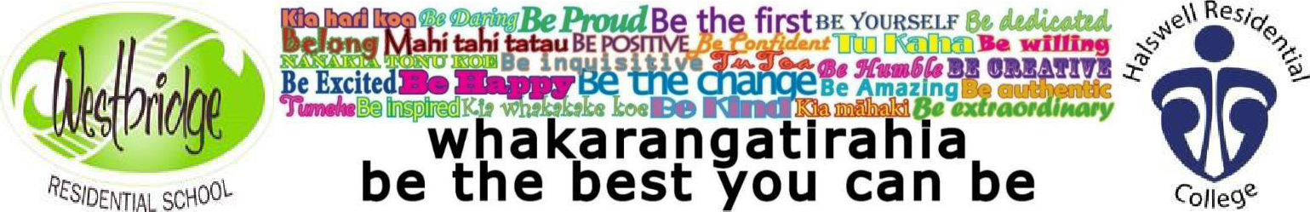

STRATEGIC GOALS
 | 2023
1. STUDENT LEARNING
The school fosters student achievement by providing teaching and learning programmes that incorporate the National Curriculum and are underpinned by the key competencies. All learning is delivered in a 24/7 teaching and learning environment where ‘living is  learning’. | - Continue to Develop and implement initiatives that are informed and inspired by an understanding of the impact of trauma. This will include the establishment of a sensory room.  - A formal Te Reo teaching programme will be established the school setting.
2. EFFECTIVE TEACHING  All staff are recognised as leaders in providing for children and adolescents with complex needs and/or behavioural needs to maximise student  learning goals. | - Continue to develop and grow staff, both day school and residential staff, through the provision of relevant professional learning opportunities. This will include a start of year key-note speaker on Trauma Informed practice.  - Establish a Functional Behaviour Analysis tool that can be used by all staff to inform best practice responses to student behaviours.
3.LEADING THE SCHOOL  Our service is cost effective, caters for the needs of all students, and represents best practice. The school inclusive, culturally responsive and safe physically and emotionally. The school has strong relationships with whanau and stakeholders. | - The Principal will work with the BOT and MOE on the redesign of the RSS pathway in order to maximize the student roll.  - The Principal will work with the BOT to continue to review/refine the RSS funding model with the MOE.  - The Principal will share the UKERU training package with the BOT, SLT and wider staff with a view to informing policy and practice.

